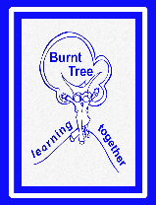      Family Support & Safeguarding Newsletter Autumn 2024  At Burnt Tree, we work closely with a range of organisations that can support your family. The Oldbury Family Hub will be delivering a healthy eating workshop (HENRY programme) on the 15th November at school, 9 am – 10.30am for parents with children in nursery, reception and year 1. Look out for the posters around school and on the website.  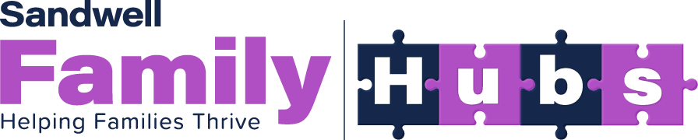    Reflexions is a Mental Health Support Team (MHST). The service aims to help increase access to mental health support for children and young people in schools.  This is a new service that has recently been introduced here. The team will be working closely with Miss Gamwell and Mrs Bryant, offering direct work with children (criteria needs to be met), parent coffee mornings, staff training, children and parent workshops, and small group work for children.  Further information can be found on the school website or you have concerns for your child’s mental health then please see Miss Gamwell or Mrs Bryant.  If interested please come along to the following Reflexions parent workshops:  16th January 2025 – Importance of sleep and the impact it has on well-being  8th May 2025 – Helping your child prepare for exams/tests (year 5 and 6)  We are collecting donations for the food bank. These can be dropped off in the school entrance.  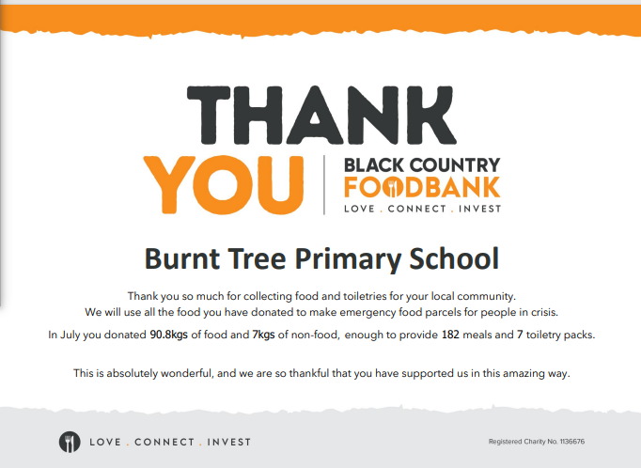 | Hello Parents/carers. I hope you find some useful information here. If you would like support, advice or have concerns for your child/ren that you wish to discuss please come in or you can find me on the gate most mornings/afternoons.  Jo Gamwell  Jo Gamwell  Useful services  Oldbury Family Hub  0121 557 0740  Have a range of resources, advice and support for families on many topics/concerns  www.barnardos.org.uk  Sandwell Young Carers  0121 525 8002  If your child is providing support to a member of your family who has a disability, ill health or become dependent on drugs/alchol then they may be eligible for this support  www.sandwellyc.org.uk  Sandwell Better Mental Health  Need to Talk? Call 0800 008 6516  www.healthysandwell.co.uk  More information on a range of services for families to access can be found at  www.sandwellfamilylife.info
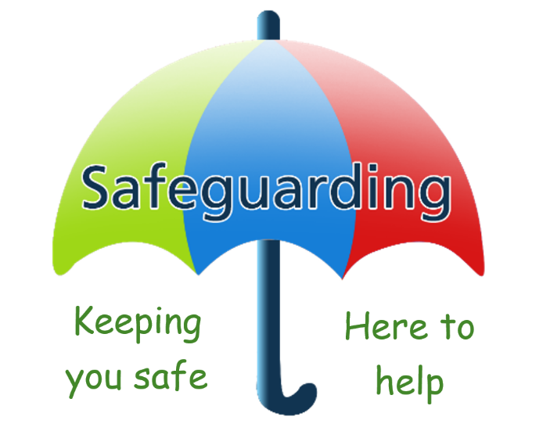  Child Criminal Exploitation  There are many forms of child criminal exploitation. All are extremely harmful to a child and their families.  Children of all ages are being groomed and exploited for the purpose of carrying out crimes.  Most common signs of criminal exploitation:  Missing episodes and being found in different areas  Having unexplained amounts of money, phones, credit etc.  Change in behaviour, secretive, withdrawn, aggression, hostile etc.  Having multiple phones, sim cards  Possession of hotel key cards, keys to properties  Relationships with controlling individuals and/ or older individuals  If you have concerns, ask for help – Police, NSPCC, Sandwell Children Services, Fearless, Barnardos, and/or talk to someone at school.  You can contact the NSPCC Helpline by calling 0808 800 5000, emailing help@NSPCC.org.uk or completing our report abuse online form. | Are you concerned about a vulnerable child in Sandwell?  If you are in any doubt, don’t delay – call 0121 569 3100 or in an emergency dial 999  www.catch-22.org.uk  Catch 22 County Lines Support and Rescue provides a specialist support and rescue service for young people and their families who are criminally exploited through county lines.  www.barnardos.org.uk  Barnardo’s services provide support to the families of children who have experienced exploitation, as well as supporting the young person.  www.crimestoppers-uk.org  Drug gangs are exploiting children and young people in your area.  CrimeStoppers.  0800 555111

