  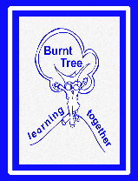    Family Support & Safeguarding Newsletter Summer Term  Summer Holiday Activities and Food (HAF) bookings are now LIVE. Looking for exciting activities to do in the Holidays? Holiday Activities are a brilliant way to try new things, make new friends and learn new skills. There is plenty of choice including sports, music, dance, art, drama, cooking, days out and much more. Check out the website to see what activities are in your area. https://holidayactivities.sandwell.gov.uk/  Registrations for families to book onto HAF provision are now live. If your child is eligible for HAF then you will have received an email or text with a HAF activity voucher containing unique HAF codes for your child and a link that enables you to book activities (eligible families will have received codes assigned by their children’s schools).  Not eligible but still looking for FREE activities in the holidays? If a child does not meet the eligibility criteria, you can find other activities and how to book via the HAF website (some activities may have a charge attached) and there is the Go Play provision, which is a FREE universal offer.  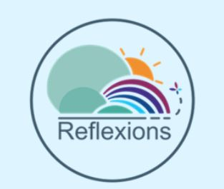  Reflexions is a Mental Health Support Team (MHST). The service aims to help increase access to mental health support for children and young people in schools.  This is a new service that has recently been introduced here. The team will be working closely with Miss Gamwell and Mrs Bryant, offering direct work with children (criteria needs to be met), parent coffee mornings, staff training, children and parent workshops, and small group work for children.  Further information can be found on the school website or have concerns for your child’s mental health then please see Miss Gamwell or Mrs Bryant.  If you are going through a crisis and need an emergency food parcel then please come into school for a Foodbank Voucher. |  | Hello Parents/carers. I hope you find some useful information here. If you would like support, advice or have concerns for your child/ren that you wish to discuss please come in or you can find me on the gate most mornings/afternoons.  Jo Gamwell  Jo Gamwell  Useful services  If you have debt issues, try your local Citizen’s Advice Bureaux (www.citizensadvice.org) or Stepchange (www.stepchange.org)  Council tax arrears contact Customer Services team on 0121 368 1155  Or check status on-line via the customers MySandwell account  Rent arrears - Frequently asked questions or get in touch with the rents team on 0121 737 5148  Benefits Check  Free community based advice (face to face and phone)  Citizens Advice and members of Sandwell Consortium  Council’s welfare rights team  0121 569 3158  Help for someone who is homeless  Please call the Housing Solutions Team on 0121 368 1166 (option 2).  Need help with your child’s behaviour? contact the Oldbury Family Hub 0121 557 0740
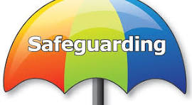  What is FGM?  - Female genital mutilation (FGM) is a procedure where the external female genitalia are partial or total removed, injured or changed for non-medical reasons.  - It is also known as female circumcision or cutting, and by other terms, such as sunna, gudniin, halalays, tahur, and among others.  - It is illegal in the UK. FGM is a practice which takes place worldwide in at least 30 countries in Africa, Asia and the Middle East. It also takes place in parts of Western Europe and other developed countries.  - It is an offence to– assist a non UK person to mutilate a girl’s genitalia abroad, assist a girl in carrying out FGM on herself outside the UK, assist (from outside the UK) a non-UK person to carry out FGM outside the UK on a UK national or UK resident  FGM is often claimed to be carried out in accordance with religious beliefs, but it is not supported by any religion.  Help End FGM – It is Child Abuse  For help and support Tel or Text 07462837349 DORCAS  Information can also be found on NSPCC website  Worried about a child?  You can contact the NSPCC Helpline by calling 0808 800 5000, emailing help@NSPCC.org.uk or completing our report abuse online form. |  | Are you concerned about a vulnerable child in Sandwell?  If you are in any doubt, don’t delay – call 0121 569 3100 or in an emergency dial 999  Physically Punishing Children Research shows physical punishment is ineffective and harmful.  University College London (UCL) and an international team of experts recently analysed 20 years of research and found physical punishment is:  - Ineffective, harmful and has no benefits for children and their families.  - Doesn’t improve children's behaviour and instead increases behavioural difficulties, such as aggression and anti-social behaviour.  - Puts children at increased risk of being subjected to more severe levels of violence.  NSPCC report that last year there were more than 500 counselling sessions delivered by Childline to young people about physical punishment.  Research indicates, children who experience physical punishment are nearly three times more likely to develop poor mental health. Being smacked also increased the chances of having difficult relationships with family and being aggressive later in life.

